NRA Pistol National Championships



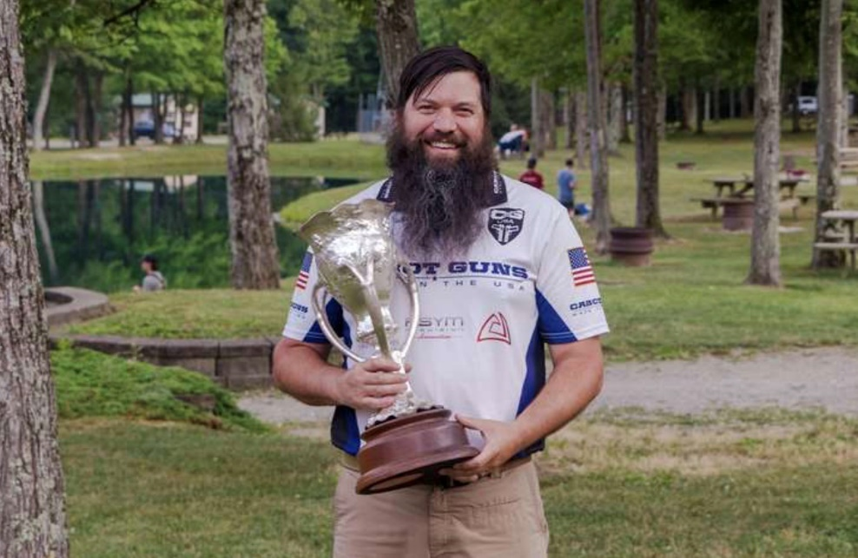
2025 Pistol Champion


Host

We want to thank all our sponsors that support the shooting sports.



NRA Championship premier Sponsor
TBD
NRA Pistol 22 Sponsor
TBD
NRA Center Fire Sponsor

NRA 45 Caliber Sponsor

Blackmass Custom, LLC.

Award Sponsors
Silver Medal
TBD
Bronze Medal
TBD
NRA Medalion Awards
TBD

Table of Contents

Cardinal Map…………………………………………………………. 5

General Information………………………………………………… 6

Pistol……………………………………………………………………… 17

Schedule………………………………………………………………. 18

NRA Pistol Championship Match………………………………. 19

Tournament Conditions…………………………………………… 21

Awards………………………………………………………………… 24

Cardinal Facilities

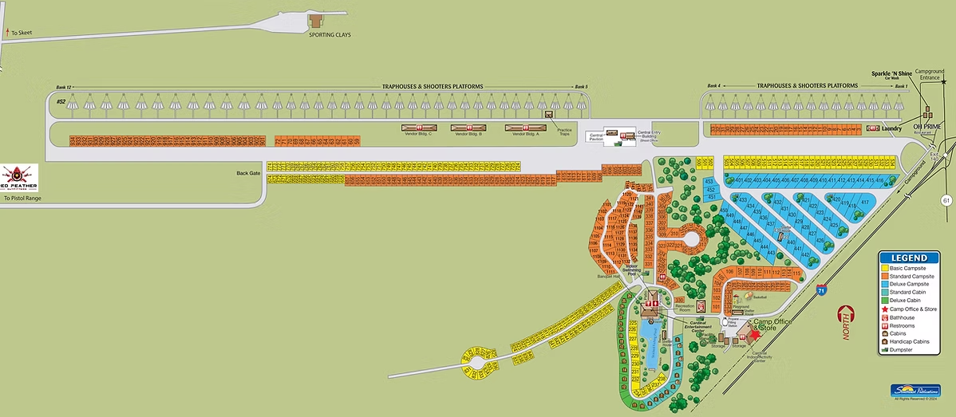

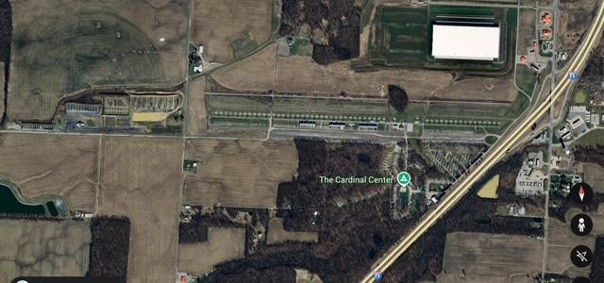

General Information

ENTRY INSTRUCTIONS

Pistol:
https://www.redfeatheroutfitters.com/nra-pistol-championship/

Online entry is strongly recommended.
- Walk up entries: Per posted Match Schedules; the above links will still be used.
- The Statistical Office is not required to accept corrections after entry closing time.
- The NRA National Championships are open to all U.S. citizens, and non-U.S. citizens who are members in good standing of their respective National Shooting Federations.

Membership in the NRA is not required, but highly recommended. National Records will be recognized for current NRA Members only.

RANGE CAPACITY
Only the first competitors as listed below will be accepted for each discipline.

Pistol: 300

OFFICIAL TIME
Eastern Daylight Savings Time. The Range Director will keep the Official Match Time.

IMPORTANT NOTICE
All competitors are responsible to be knowledgeable of all rules, regulations and contents of this program (NRA Rule 18.15). https://competitions.nra.org/media/10579/2026-precisionpistol_rulebook.pdf
For medical waivers follow this link: https://adaptiveshooting.nra.org/competition-waiver-program/
Waiver approvals must be obtained in advance of the match.

Everyone involved in these National Matches must understand that in accordance with NRA Rule 11.1 and 11.4, the NRA Match and Range Directors have complete authority to make any last-minute changes they deem necessary to ensure that the competitions are run smoothly and safely. This may include changes in relay and squadding schedules and cancellations of firing altogether.
Any such changes will be relayed to the competitors via announcements, Match Director Bulletins, and/or mass E-mails/texts.

ELECTRIC VEHICLE CHARGING
There are no electric vehicle charging stations at Cardinal shooting Center. Charging an electric vehicle through any means at Cardinal is prohibited.

ON-SITE VENDORS
There will be limited vendor space available.

RESULTS BULLETIN
Preliminary Results Bulletins will be posted outside the Statistics Office. Preliminary results are continually updated at https://www.thecardinalcenter.com/pistolrange

AWARDS OFFICE LOCATION
The Cardinal match Awards Office is in the Red Feather Outfitters (RFO) building. W9 information will be collected during the Award Payout.

FIREARMS AWARDS POLICY
Effective immediately, it is the policy of the National Championships not to award firearms to junior competitors that are not of legal age to receive the firearm directly from the FFL holder.
Firearms will also no longer be awarded to junior teams where the Team Captain is not of legal age to accept the firearm directly from the FFL holder.

FOREIGN COMPETITORS
Foreign competitors will be exempt from the electronic W-9 collection process. They will be required to complete a Form W-8 upon award payout.

COMPETITOR PACKETS
- All competitors who register will receive a packet
- The packet contains all materials needed to participate in the National Championship.
- The label on the packet indicates all entry information, class, category and address. Please double-check this information and indicate any needed changes.
- The name badge will be required at all award ceremonies and prize tables. The name badge, along with photo ID may be required to prove participation in the National Championship at Cardinal.
- Packet pickup dates
Pistol Registrants shooting the prelim matches: July 4th
Pistol 2700 July 5th
Pistol side matches and EIC matches can be picked up no later than the morning of that match.

ADULT SPONSORS, JUNIOR ENTRIES

All Juniors 17 years and under must be accompanied by an adult sponsor. An adult sponsor is defined as a person 21 years of age or older. The adult sponsor is responsible for the behavior and welfare of those individuals sponsored and must be housed with the sponsored juniors if Cardinal lodging is used. No housing will be made available to individuals younger than 18 years of age.

JUNIOR COMPETITOR ELIGIBILITY
Individuals may compete as juniors in Individual or Team competition at the NRA Championships, provided they meet the following criteria:
- Must comply with Rule 2.3 Junior, 2.3.1 Intermediate Junior and 2.3.2 Sub-Junior.
- Where there is only one junior team in a classification, they will be combined in accordance with the National Championship Program until a minimum of two teams are reached in an award classification. If there are no other junior teams entered, they will be combined with adult teams in the appropriate classification. The combining orders are listed in the program.
- Packets may not be picked up early.
Packets must be picked up by the named competitor.
- A competitor registered in more than one
Championship will receive more than one packet.

CHANGES
If you have any changes to make in your entry, your options
- Email tylerm@thecardinalcenter.com
- provide correct information at packet pick-up

CANCELLATIONS AND REFUNDS
Refunds will not be made until a written cancellation request is received. No refunds will be made for those individuals who do not show up at Cardinal Shooting Center and make no attempt to contact the Statistical Office. REFUNDS WILL NOT BE MADE TO THOSE COMPETITORS WHO HAVE FIRED IN ANY EVENT AND THEN WITHDRAW FROM THE TOURNAMENT.
- Send an email to tylerm@thecardinalcenter.com with details including Championship, name, competitor number, phone number, etc.
- Mail cancellation to:
Red Feather Outfitters
ATTN NRA National Entries
3547 County Rd 225
Marengo, OH 43334
- Deadline: June 15th, 2026
- A cancellation fee of 10%, not to exceed $25, is assessed against any cancellations before the above date.
- A cancellation fee of 30% is assessed against any cancellations after the above date.

MATCH CANCELLATION BY MATCH DIRECTOR
If the Match Director cancels any individual match(s), entry fees will not be refunded. However, entry fees for canceled team matches will be refunded to Team Captains only, by mail, after the National Matches are completed. The team score card for the cancelled team match must be returned to the Stat Office before a refund can be made. If a match is canceled, the Match Director may reschedule that match. It is the competitor's responsibility to provide ample ammunition should this happen.

AUTHORIZED ASSISTANCE
Individuals who have a physical disability which precludes them from conforming to the time schedule for changing targets must have a waiver from the NRA Protest Committee allowing them to have assistance with target changing and moving equipment to and from the firing line.
For medical waivers follow this link: https://adaptiveshooting.nra.org/competition-waiver-program/
Waiver approvals must be obtained in advance of the match.
Should a competitor sustain an injury at the competition and finds they need assistance to continue the match, a Match Director and NRA referees assigned to handle such events will make accommodation decisions.

SMOKING
There will be no smoking, including but not limited to cigarettes, cigars, pipes, e-cigarettes or vape devices, allowed forward of the Ready Line. A designated smoking area will be set 25 yards behind the center line unless otherwise directed by Match Director.

HEARING IMPAIRED COMPETITORS
It is the responsibility of competitors who are hearing impaired to inform the Range Officer each time they go to the firing line.

EMERGENCY CONTACTS
Primary Emergency telephone number is 419-253-0190 or 419-253-0800

WELCOME CENTER / Registration Office
All National Match participants, including support personnel, will in-process as follows:

Stop 1: Red Feather Outfitters building / NRA Entry
- Sign eligibility affidavit and liability agreement
- Pick up Entry Packet
- Verify all contents for correctness

Stop 2: Cardinal Campground Office (those who have reservations and volunteer staff)
• Receive housing assignment and keys for all individual and non-junior assignments

VEHICLE PARKING AND ENFORCEMENT
Golf Carts:
Golf carts will be allowed on the ranges for use by competitors and staff. The Match Director and NRA Match Coordinator will coordinate the use of all golf carts. IF this becomes a conflict with the conduct of the National Championships, disrupts Range Operations, or causes destruction, the Match Director will issue further guidance in the form of a Match Director Bulletin. Operators should have a valid State Driver's License. Golf Cart operators must obey all traffic laws and signs.
Golf carts may be driven anywhere on Cardinal Shooting Center property.
Please try to combine competitors on the golf carts as much as possible to minimize the number of carts at a given time to allow for competitor equipment and spectators. We do not want to infringe on the assembly line, ready line and firing line.
Please use the utmost courtesy when transporting yourself, equipment and passengers. We would like to make this an enjoyable experience and addition to the NRA National Championship matches.
Parking for the shooting range is located immediately behind the range.

LAW ENFORCEMENT
Enforcement and traffic direction will be performed by the Ohio State Police, and Morrow County Sheriff's Office.
Observe all traffic laws and signs, particularly speed limits.

NRA HEADQUARTERS - NATIONAL CHAMPIONSHIP PROTEST COMMITTEE
Offices of the National Match Coordinator, Match Director, Chief Range Officer, Chief Referee, Statistical Director, Press Operations, National Championship Protest Committee and Range Engineer are located in Red Feather Outfitters building.

WEATHER CONDITIONS
Weather at The Cardinal Shooting Center is quite variable. Clothing for hot, cool, and wet conditions should be brought.

PETS
Pets are permitted at the Cardinal Campground, must always be on a leash, and owners are responsible for keeping the area clean. Service Dogs are permitted with documentation.
Documentation for Service Dogs shall be presented at Lodging when checking in.

LOST AND FOUND
The lost and found is located at the RFO building. It is strongly suggested that all personal items be permanently marked so easy identification can be made if lost. At the close of the NRA National Championships, any useful equipment will be donated to a junior program. Otherwise, lost and found items will be disposed of by the Cardinal Center.

TAILGATING OPERATIONS POLICY
There will be a Swap meet for competitors. See the match schedule and location. The swap meet is permitted as long as there are no sales of firearms on Cardinal grounds. These will be strictly competitor driven and may be located at the pistol range parking lot up to 3 hours after the end of the match on the scheduled day, except when there is an award ceremony.

PROPER ATTIRE
In keeping with the tradition established by NRA and The Cardinal Center during shooting events, and recognizing the publicity attracted by the National Championships, it is important to promote an acceptable image for competitive shooting. Attire worn during all phases of the Championships should be in good taste and appropriate to such a prestigious sporting event. Articles of clothing with controversial or offensive slogans or illustrations are prohibited. The Match Director is empowered to take whatever action is necessary to maintain acceptable clothing standards.

LODGING
General
Cardinal Campgrounds consists of Cabins (suites and standard) as well as the RV and primitive Campground.
Lodging is controlled by the Cardinal Campground not by the NRA. Entry fees DO NOT include lodging costs.
Lodging facilities are available for competitors, team officials, sponsors, and accompanying family members. Requests for lodging in specific locations, or with designated individuals, are not guaranteed.
Reservations
- Call the Cardinal Campground @419-253-0800 between 9:00am and 4:00 pm eastern, Monday - Saturday. Email: cccoffice@yahoo.com
- Reservations will be accepted by telephone, beginning April 2026
Reservations are assigned on a first come, first serve basis.
- Provide your arrival and departure dates, along with names and addresses of any roommates.
- Provide payment info - Credit Card (MC, VISA, AX and DS) as well as cash/ check payments.
- A valid credit card is required to secure all future reservations.
- All guests must be 18 years or older and have a valid ID
Check in / Check out
- All guests must pay at the time of reservation.
- Check in at 3:00 p.m.
- If arriving after 5:00 p.m, guests can call the camp office @ 419-253-0800 and make arrangements for cabin keys to be left in their cabin.
- You will be given a confirmation number at the time of your call. Please keep this number somewhere safe; you will need to have this number to make changes to your reservation and
- Check-out in the Cabins and campground must be no later than 11 a.m. Additional charges will be incurred for late checkouts.
- No refunds for early departures will be granted.
- Final changes to reservations, departure date, number of beds/rooms, etc., must be made at check-in.

Lodging Fees
For current fees contact the Cardinal Campgrounds Office at 419-253-0800 or by email @ cccoffice@yahoo.com
No fees for main housing or campsites are to be sent with the entry fees. Housing fees will be paid at the time of the reservation.
Lodging Reassignment
NO reassignment of lodging is to be done without the prior knowledge of the Cardinal Camp Office.

Security of Property
Occupants bear total responsibility/liability in the event of loss of property through fire, theft, and damage or for any other reasons while at Cardinal Shooting Center. Vandalism will not be tolerated and anyone caught in such an act will be turned over to the Ohio law enforcement authorities for appropriate action.

Red Feather Outfitters / pistol range control is a large facility that will act as the National Championship Headquarters. Almost everything associated with the 2026 National Championships will be held in this building. This includes competitor meetings, Competitor Check in, competitor changes, Data entry, complaint department, lost and found, staff meetings, trophy display, volunteer check in, question department - everything. When entering the building, please be cognizant of this and don't yell. The hours of operation will be posted on the door. We will strive to settle all challenges and protests each day. Please check results, online or displayed, often.

Food Service/Meals
Lunch and dinner options for each day are available for purchase on the signup site.
Food will also be available for lunch and dinner at several locations on Cardinal grounds and next to the Entrance to include Subway, Arby’s, and the “OH Prime” restaurant.

HOTELS / CAMPGROUND
Camper Rentals Adventure Bound Rentals 614-686-6111

Hotels are available in the area with possible discounts for competitors.

Hampton Inn Columbus/ Delaware
7329 US-36, 37
Sunbury, OH 43074

Microtel Inn and Suites by Wyndham
7323 OH-37 east
Sunbury, OH 43074

Holiday Inn Express
7301 OH-37 east
Sunbury, OH 43074

SAFETY
General
Safety in the use of firearms and in other activities is the responsibility of all who participate in the National Championships, whether competitors, dependents, team officials, volunteers, or Match Staff. In order to maintain the outstanding safety record at Cardinal Shooting Center, safety rules must be observed.
Violation of the following rules may result in disqualification and/or expulsion from the Cardinal Shooting Center with no refund of fees:
- When operating a motor vehicle on Cardinal Grounds, observe all posted speed limits, parking restrictions, and road signs.
- Because of fire hazards in the competitor housing area, the following actions are prohibited:
  - Smoking in bed or open flames of any kind.
  - Charging Electric Vehicles
  - Toaster Ovens.
- Test firing requires a receipt available at Red Feather Outfitters store. Test firing range will be in Range 4 Bay 1.
NOTE: Any person violating of the range safety and test firing locations will be removed from the property and forfeit all match access and fees.

3. The following actions involving firearms safety are prohibited:
- Loading and/or firing of any firearm before the command "Load" has been given.
- Carrying or possession of an uncased firearm with the action closed, except when actually on the firing line at an assigned firing point, or in an authorized dry firing area.
- Having a loaded firearm on Cardinal grounds except when on an assigned firing point after the command "Load" has been given. (A loaded firearm is defined as having a round or rounds in a chamber, cylinder, or on a loading ramp; or having a magazine or clip containing one or more rounds partially or fully inserted in the firearm.)
- Leaving a magazine or clip in a firearm or having the action closed after the firing line has been cleared.
- Handling a firearm in any way on the firing line while anyone is forward of the firing line.
- Any other unsafe act involving a firearm.
- The use of eye and ear protection is required for Pistol competitors are required to wear eye and ear protection Rule 3.19 and Rule 3.20
- Empty Chamber Indicators (ECI) are required for the
NRA National Championships.

Dry Firing
These rules apply to all dry firing during the National Championships:
- Dry firing is permitted during the time that a competitor is on the firing line and is preparing to fire in accordance with Rule 10.3.1.
- No dry firing is permitted in any area of Cardinal Shooting Center other than stated above.
- No ammunition is to be in the possession of competitors when they are dry firing except as in paragraph (1) above.
- When dry firing, all competitors must open actions and observe all other range safety precautions when other persons approach their line of sight.
- Any dry firing must be done on the firing line or as directed by the Match Director.

Alcoholic Beverages or Narcotic Substances
Consumption of any alcoholic beverage or narcotic substance, which can alter the normal mental or physical function of the body, either on the range or in the spectator or public areas south of Hendricks's Ford Road while the ranges are in use, is prohibited. The use of any narcotic substances ANYWHERE on Cardinal grounds is prohibited. Disorderly conduct or intoxication is not permitted on the range or on any contiguous range property. A person who violates this regulation will be subject to immediate disqualification and expulsion from the National Championships with no return of entry fees.

Entry Information

COMPETITOR CLASSIFICATIONS
- All competitors who do not hold an NRA Official Classification, either in the type of competition being fired, or an Assigned Classification according to section 19 of the appropriate rule book, will be placed in the Master class.
- Competitors may be required to present an Official NRA
Classification Card at the Entry Office before picking up their competitor packet.

ENTRY CLOSING DATES
No US Mail entries will be accepted. Please email tylerm@thecardinalcenter.com or call RFO @ 419-253-0190 for assistance.
On-site Team Entry: 4pm, day before the match Pistol: July 4, 2026 @ 4pm

ENTRY FEES
- Individual Entry Fees for the NRA Championships do not include housing fees.
- Entry fees must be paid by American Express, Discover,
VISA or MasterCard.
- Non-Firing Registration: Everyone going down range must process through the NRA Stat Office.
- Spectators, family members, children - all persons not participating in matches, must go to the NRA Stat Office and sign the waivers.
- Coaches, Captains, and Scorekeepers - any non-Firing
Team Member - must register on-site to obtain a name badge and labels.

NRA PISTOL ENTRY FEES
2700 Aggregate Package:
Open/Metallic or. 22 Only Championship. $200
Juniors. $115
4-Person Team Entry Card. $120
2-Person Team Entry Card. $80

Single-Day Championship
Individual. $90
Juniors. $50
4-Person Team. $75
2-Person Team. $30
3-Person Preliminary Team Match $60

Side Matches
Individual Preliminaries $35
Harry Reeves. $20
Distinguished Revolver. $20
EIC Matches. $20
Service Pistol .22 Rimfire. $20

NRA Championship T-Shirt Pre-order with registration $45 Online Pre-Order before
June 15 Select size

Tournament Conditions All Championships
- All matches fired on the same day regardless of the time are considered to be fired under equal conditions.
- Not all competitors need to complete a given match before another match has begun.

RULES
Current NRA Rules will govern the conduct of these
Championships except as modified within this program.
It is the competitor's responsibility to be familiar with the appropriate rule books and program. As per section 11 the Match and Range Directors have complete authority to make any changes as necessary for smooth operation and safety of the matches.
https://competitions.nra.org/media/10579/2026-precisionpistol_rulebook.pdf

TARGET CHANGING AND HANDLING
Listed targets will be placed in frames and changed by competitors.

SCORING
Each competitor will score the target to the left, except for those firing on the first target on a line, whose scoring duties will be performed by National Match personnel. In Team Matches, each team must supply a scorer for another team. The decision of the Scoring Referee is final.

USE OF SCORING DEVICES
No competitor will use an “Eagle Eye “ or scoring plugs of any kind on a target at any time. The Referee, or designee, will plug shots under contention.

Competitors may use standard NRA overlays per Rule 14.3.1.

SCORECARDS
- Scorecards are provided to each competitor in the competitor packet. Upon receipt of the packet, each competitor should check immediately to be sure that a complete set of scorecards is enclosed. Each competitor must make certain that the correct scorecards are used for each day's firing.
- DO NOT cross out match numbers and substitute others.
NRA championship scorecards are provided in sets, as a booklet. If the cards are removed one by one, there should be no incorrect scorecards used, as the booklet is set up in the order in which the matches are fired.
- All scorecards used in the matches and all team cards
MUST BE labeled with self-adhesive labels (supplied in each competitor's packet). Make certain that you place your current year's labels on your scorecards before you go to the range. Unidentifiable scores will not be used.
DO NOT use felt-tip pens to fill out scorecards.
- All scorecards must be turned into a line official within10 minutes of completion of firing a match. Score keepers are reminded to place their label on the back of the score card prior to turning in. Failure to do so may disallow that score for awards.
- Failure to use the proper scorecard will result in a score of "0".
NOTE: Competitors who appear at the firing line without scorecards will be required to purchase duplicate scorecards at a cost of $5 per scorecard. It is the competitor's responsibility to have the correct change.
- When signing scorecards, the competitors must remember they are signing for the value of each shot indicated on the card. Each competitor is responsible for their own scorecard. See Rule 18.14.
- When scoring, place a competitor label on the back of the score card.

ELECTRONIC DEVICES

Rule 3.22 states competitors are responsible to ensure all electronic communications and audio devices in their possession forward of the ready line are silenced and communication disabled.
- Radars, chronographs and other devices designed to measure bullet velocity are prohibited on the line.
- Cellphones rendered silent and incapable of communicating are permitted on the line.

CHALLENGE AND PROTEST PROCEDURES
See Rule 16 in each discipline’s Rulebook
Reminder: Rule 11. 8.. decisions on Protests by the National Championship Protest Committee are final.

PROTEST FEE
Protest fee. $20

PISTOL CHALLENGE FEES
Individual Matches (per challenge). $ 5
Team Matches (per challenge). $ 10

CHALLENGE PERIOD
- All scoring challenges must be made on the range for pistol. All challenges must be made before the end of the challenge period, which is 5 hours after that days scores are posted, that 5 hour time will freeze 9PM to 8AM.
- The Stat Office will strive to complete all challenge periods to end on the day of the match. The Stat Office will remain open to achieve this.

COMPETITOR MEETING
Members of the Committees who are present during the matches will meet to discuss NRA competition programs and Rules. All NRA members and competitors are encouraged to attend and contribute to the proceedings.
All meetings will be held in RFO.
COMPETITOR MEETING DATE Tuesday July 7th, 2026

BULLETINS
Preliminary Scores will be posted outside the Stat Office in the lobby of Red Feather Outfitters.
The Challenge Period will be noted. Competitors are reminded to check these scores promptly and report errors within the Challenge Period.
NOTE: Failure to check scores within the time limit results in the penalty of losing the privilege of any further challenge. (See Rule 18.13) In team matches, only the Team Captain may report errors.
Awards Bulletin: An Official Copy of the results will be posted at https://www.thecardinalcenter.com/pistolrange
REFIRING
Any refiring will be at a time and place specified by the Range Director or designated representative.

AWARDS & CEREMONIES
All awards will be presented at the Awards Ceremonies.
The Ohio Rifle & Pistol Association will have refreshments. All Award Ceremonies will be held at The Cardinal Shooting Center Banquet Hall.
Award ceremony times will be announced at the cease fire of the final match in the Championship. The Stats Office will strive to hold the Ceremonies within three hours of cease fire.
Award Ceremony schedule:
Wednesday, July 8, 2026

AWARDS
The following awards will not be mailed: medals, plaques, prize table items. Awards and Prize Table items not claimed at the Awards Ceremony will become property of The Cardinal Center. Anyone not attending the Awards Ceremony forfeits their claim to any items. Award checks will be mailed by the Cardinal Center after August 28. It is highly recommended that class willers attend the Awards Ceremony.

In matches issuing place awards:
Place Awards are First Place, Second Place and Third Place
Five competitors minimum for First Place, ten competitors minimum for Second Place, fifteen competitor minimum for Third Place.
Place Award winners are eligible for Special Awards.

Competitors are divided into Divisions. Pistol Divisions are Open and Metallic. See Match Rules for each. Championship for these Divisions. The Divisions are divided into Regular Award Categories are Civilian, Service, Police
Competitors choose one Regular Award Category and may not change from one Regular Award Category to another during any one phase of the National Championships. Regular Award recipients can be determined by following these rules

Civilian NRA rules 2.2
Service NRA Rules 2.5, 2.6, 2.7
Police NRA Rule 2.4

Competitors should check all Special Award Categories that apply during Registration. In these Championships, competitors are allowed one age-appropriate Special Award Category. This age-related Special Award Category is the category that corresponds to the year of her/his birth. Requirements for these
Special Award Categories are spelled out in Rule 2.

The Special Award Categories are a little different in each Championship. They are listed in the Tournament Conditions or Match Awards.

Class Awards are presented based on competitor's NRA
Classification: High Master, Master, Expert, Sharpshooter, and Marksman.
If there are less than two (2) competitors in an Awards or Class Category, the Award will not be presented.
Junior or Collegiate competitors in the Service will compete in the Service Category and pay standard fees. Junior or Collegiate competitors in the Service are not eligible for Junior and Collegiate awards.

NATIONAL
PISTOL
CHAMPIONSHIPS 2026
July 4th – 8th, 2026

National Championships Staff
Match Director – Dane Hogle
Range Engineer – Tyler Milligan
Chief Referee – Kenn Boyd
Statistical Director – TBD

Contact Information
For information regarding the Championship email the Tyler Milligan at @ tylerm@thecardinalcenter.com

SCHEDULE OF EVENTS
All times and locations are subject to change.

July 4th Saturday
10:00- 17:00 Registration
Early packets pick up
Paid practice
Dusk Campground Fireworks Display

July 5th Sunday
08:00- Registration opens
10:00- Opening ceremonies
11:00 - Harry Reeves revolver match
12:30- Preliminary 900 relay 1
14:30- Preliminary 900 relay 2
Preliminary 900 relay 3 TBD
16:30- Preliminary Team Match

July 6th Monday Sponsored by: Ultradot
08:00- Relay 1 .22 900
10:00- Relay 2 .22 900
12:00- Lunch
Relay 3 .22 900 TBD
12:30- Team .22 matches
14:00- .22 EIC
16:00 Swap Meet
17:00 Open grill and social

July 7th Tuesday Sponsored by: Walther
08:00- Relay 1 CF 900
10:00- Relay 2 CF 900
12:00- Lunch
Relay 3 CF 900 TBD
12:30- Team CF matches
14:00- NRA distinguished revolver
17:00- Competitors meeting
18:00- Optional Shooters Dinner (Pre-order)

July 8th Wednesday Sponsored by: TBD
08:00- Relay 1 .45 900
10:00- Relay 2 .45 900
12:00- Lunch
Relay 3 .45 900
12:30- Team .45 matches
14:00- Service pistol EIC
18:00- NRA Cardinal Awards Program

July 9th Thursday (if needed) make up day

CHAMPIONSHIP MATCHES

AGGREGATE MATCHES
MATCH 100: NATIONAL PISTOL CHAMPIONSHIP
This is an aggregate of each competitor’s total score fired in matches 101, 102 and 103.
MATCH 113: .22 CALIBER ONLY CHAM PIONSHIP
This is an aggregate of each competitor’s total score fired in matches 101, 102 and 103 fired using a .22 caliber only. See NRA Pistol Rulebook Section 22.

SUB-AGGREGATE MATCHES
MATCH 101:.22 CALIBER CHAMPIONSHIP
135 .22 Caliber Slow Fire
136 .22 Caliber National Match Course
137 22 Caliber Timed Fire
138 .22 Caliber Rapid Fire
MATCH 102: CENTER-FIRE CHAMPIONSHIP
139 Center-fire Slow Fire
140 Center-fire National Match Course
141 Center-fire Timed Fire
142 Center-fire Rapid Fire
MATCH 103: .45 CALIBER CHAMPIONSHIP
143 .45 Caliber Slow Fire
144 .45 Caliber National Match Course
145 .45 Caliber Timed Fire
146 .45 Caliber Rapid Fire

SIDE MATCHES
MATCH 111: PRELIMINARY CHAMPIONSHIP
Aggregate of stages 132, 133, 134
Course of Fire: National Match Course.
Stage 132 - Slow Fire, 10 rounds
Stage 133 - Timed Fire, 10 rounds
Stage 134 - Rapid Fire - 10 Rounds

MATCH 131: HARRY REEVES MEMORIAL CHAMPIONSHIP
Firearm: See Rule 3.5
Course of Fire: National Match Course as stated in Chapter 7

MATCH 147: NRA DISTINGUISHED REVOLVER
Firearm: See Rule 3.3
Course of Fire: National Match Course as stated in Chapter 7

Awards:
As stated in Section 23 of the rule book.

POSTAL MATCH
MATCH 1000: MAYLEIGH CUP POSTAL MATCH
We are not holding this match this year, there is no competition.

TEAM MATCHES
Note: all coaches and captains must register at the Statistical Office and get stickers. Processing could take up to an hour, plan accordingly.

AGGREGATE TEAM MATCH #112 - 4 PERSON TEAM (FIRED)
Coming Thru the Rye Team Trophy Match
Aggregate of Matches 121, 122, 123
Course of Fire:
Fired Match 121 - 22 caliber
Fired Match 122 - Center Fire
Fired Match 123 - 45 caliber

Open to:
Between four and six firing team members may be listed as firing members. Each team member must fire in at least one of the daily fired team matches to receive awards.
Competitor stickers must be on the Entry Card and turned in to the Statistical Office before registration closes. Team Members, Captains and Coaches can only be a part of a single team throughout the three days of the Pistol National Aggregate Team Matches.

MATCH 117: .22 ONLY, 4-PERSON TEAM AGGREGATE
Match 118 22 Caliber Stage 4-Person Team
Match 119 22 Caliber Stage 4-Person Team
Match 120 22 Caliber Stage 4-Person Team

AGGREGATE MATCH 114 - 2 PERSON TEAM
Aggregate of Stages 124, 125, 126
Course of Fire:
Fired Match 124 - .22 caliber
Fired Match 125 - Center Fire
Fired Match 126 - 45 caliber

AGGREGATE MATCH 116 - 2 PERSON .22CAL TEAM
Aggregate of Stages 127, 128, 129
Course of Fire:
Fired Match 127 - 22 caliber on .22 Day
Fired Match 128 - 22 caliber on Center Fire Day
Fired Match 129 - 22 caliber on .45 Day

Match 114 & 116 Open to:
Between two and three firing members may be listed as firing members. Each team member must fire in at least one of the daily fired team matches to receive awards.
Competitor stickers must be on the Entry Card and turned into the Statistical Office before registration closes. Team Members, Captains and Coaches can only be a part of a single team throughout the three days of the Pistol National.

MATCH 115 - 900 POINT PRELIMINARY 3-PERSON TEAM MATCH
Aggregate - Total Team Score
Course of fire: NMC for each of the following
22 Caliber - Center Fire - .45 Caliber
Stage 1 - Slow Fire, 10 rounds
Stage 2 - Timed Fire, 10 rounds
Stage 3 - Rapid Fire - 10 rounds
Open to:
Three Person Teams
All three team members will fire simultaneously. One team member fires.22, one team member fires Center Fire and one team member fires .45. This match is not part of the National Championship.

TOURNAMENT CONDITIONS

FIRING TIMES
Firing will begin daily at 8 am EDT.

OFFICIAL TIME
Eastern Daylight Savings Time. The Range Director will keep the Official Match Time.

INDIVIDUAL DIVISIONS
Open, Rule 3.2(a)
Metallic, Rule 3.2(a)
.22 Only, Rule 3.4

REGULAR AWARD CATEGORIES
Competitors will choose one of three categories per Section 2 of the NRA Pistol Rules. Competitors may not change from one category to another during any phase of the National Championship. This category will be used along with special categories for aggregates and the National Championship.
Civilian
Service
Police

SPECIAL AWARD CATEGORIES
Special Award categories are defined in the Match Awards. In order for a competitor to be included in any special awards category for which they may be eligible, the appropriate category must be indicated on the Registration. Competitors may be eligible for more than one special category.

INDIVIDUAL CLASSIFICATIONS
All competitors who do not hold an NRA Official Classification in the type of competition being fired or an assigned classification will be placed in the Master Class. Rule 19.2

JUNIOR COMPETITOR ELIGIBILITY
Individuals may compete as juniors in either Individual or Team competition at the NRA Championships, provided they meet the following criteria in NRA Rule 2.3, 2.3.1, 2.3.2.

TEAM ENTRY INSTRUCTIONS
There are 4-Person Team matches, 2-Person Team matches, and one 3-Person Preliminary Team match. Team Captains are requested to purchase team cards on-line and finalize at Registration Office prior to the close of registration.
Completed forms will include the team’s name, club or organization, Team Captain's name and competitor number. Team Captains must provide a complete address on the back of each team entry card. The address will be used for the return of entry fees due to canceled matches.
Team members need not be listed on the "Official" Team scorecard until the first competitor goes to the firing line.
See NRA Pistol Rule 12.3 and 12.4. Disqualified teams will not be reimbursed entry fees.

TEAM ELIGIBILITY
Teams may enter under the following NRA Pistol Rules 2.10-2.14, and 2.19. Team members cannot be firing members of a 4-Person team and a 2-Person team. No team may enter more than one 2-Person team in a 2-member team match.
See NRA Pistol Rules 2.11, 2.12, 2.13 and 2.14.

TEAM CATEGORIES
Teams will be divided into 3 categories per Section 2 of the NRA Pistol Rules. Competitors may not change from one category to another during any phase of the National Championship. This category will be used only for possible National Records during the National Championship.
Open, Service, Police, State Association

TEAM SPECIAL CATEGORIES
Junior, Military Veteran

OPEN TEAMS
Open teams may consist of 2- or 4- members without restriction on residency or club membership.

STATE ASSOCIATION TEAMS
Teams representing organizations must all be members of the same organization. No more than two non-civilian competitors may be members representing a State Association Team.

SERVICE AND POLICE TEAMS
Service, National Guard, or other Armed Forces Reserve teams, Captains and Coaches must have been members of their respective services for a continuous period of at least 30 days immediately preceding the day of competition.

JUNIOR TEAMS
Any Open or State Association team, where all firing members are Juniors may compete for the High Junior Team award in each NRA Team Match. The Team Captain must mark team cards as "Junior" before final entry. See NRA Pistol Rule 2.3.

TEAM CLASSIFICATION
Team classifications will be determined using the table in
NRA Pistol Rule 19.12. The Tyro designation will not be used.

FIREARMS ALLOWED
See NRA Pistol Rules Section 3.

TRIGGER WEIGHING REQUIREMENT
During NRA Pistol Championships, trigger-weighing stations will be available by the on-site gunsmiths.
Pistol triggers will be subject to random checks on the firing line. Substitution of pistols (except under provision of NRA Pistol Rule 9.1 will result in disqualification. See NRA Pistol Rules.

AMMUNITION
See NRA Pistol Rule 3.17.

TARGETS
Pistol B-6 and B-8

FIRED TARGETS
All fired targets will remain under control of The Cardinal Center.

TARGET CHANGING AND HANDLING
Pistol targets will be placed in frames and maintained by the competitors. Repair centers will be used, Shooters will be responsible for Staplers and Pasters. Full replacement targets will also be available.

LOGISTICS

CONTACT INFORMATION
For information regarding the Championship email at tylerm@thecardinalcenter.com or call 419-253-0190.

SQUADDING
Competitors are squadded on the same target throughout the individual Championships. The Position number will not change, and Relay 1 will always be first. Squadding will be posted at packet pick up. If we have 3 relays we will rotate relays, if we only have 2 relays you will not rotate them.

It is the competitor's responsibility to be present when their relay is called to the firing line. No one will be allowed to set up on the firing line after the end of the 3-minute preparation period.

AWARDS

Competitors are only eligible for awards in the Championship they choose to compete in. Any competitor who equals or betters the score of the Individual or Team setting a National record in an NRA Match or Aggregate will be mailed a special certificate indicating this accomplishment. In order to be eligible for National Records, competitors must meet certain requirements per NRA Pistol Rule 17.

INDIVIDUALS
Individuals receiving first, second, or third place awards are not eligible for class and category awards but are still eligible for special category awards in the same event.

JUNIORS
There must be two or more juniors in order to establish first place awards. Five juniors are required to establish second and third place awards.

TEAMS
Teams will not be divided into classes or categories. There must be two or more teams in order to establish first place awards. Five teams are required to establish second and third place awards.

AGGREGATE MATCHES
MATCH 100
National Champion Open Division -
Harrison Trophy Plaque, $200
2nd Silver Medal, $100
3rd Bronze, $50
National Champion Metallic Division -
Hamilton Trophy Plaque, Gold Medal, $50

MATCH 100: JUNIOR NATIONAL CHAMPION
Champion Gold Medal
2nd Silver Medal
3rd Bronze Medal

MATCH 100: REGULAR AWARD CATEGORIES
Civilian - Manchester Trophy Plaque $25
Police - Thomas McGinley Trophy Plaque $25
Service - Gold Medal, $25

MATCH OVERALL CLASS AWARDS
High Master |Master | Expert | Sharpshooter |Marksman
1st Gold Medal $50

MATCH 100: SPECIAL AWARD CATEGORIES

Woman $25 Alexander Trophy Plaque
Civilian Woman $25 Vincent Trophy Plaque
Senior $25 Gold Medal
Grand Senior $25 Gold Medal
Collegiate $25 Gold Medal
National Guard Senior $25 Gold Medal
Air Force. $25 General Twining Trophy Plaque
Military Veteran $25 Gold Medal
High Junior Volunteer Trophy Plaque
National Guard $25 Patrick O Powell Memorial Trophy Plaque
Army Reserve $25 Army Reserve Pistol Trophy Plaque

MATCH 113: .22 ONLY CHAMPION
1st $ 100 Gold Medal
2nd $ 50 Silver Medal
3rd $ 25 Bronze Medal

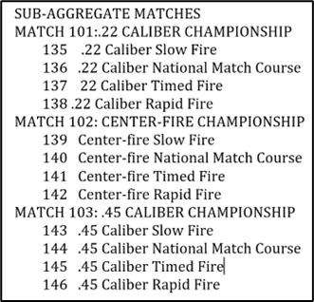
SUB-AGGREGATE MATCHES

MATCH 101 – 103 Overall
1st $10 Gold Medal
2nd Silver Medal
3rd Bronze Medal

MATCHES 101 - 103: CLASS
High Master |Master | Expert | Sharpshooter |Marksman

MATCHES 101-103 AWARD CATEGORIES
Match 101 - High Master 22 Cal Champion Walker Trophy Plaque, $10
Master 22 Cal Champion Walker Trophy Plaque, $10
Expert 22 Cal Champion Walker Trophy Plaque, $10
Sharpshooter 22 Cal Champion Walker Trophy Plaque, $10
Marksman 22 Cal Champion Walker Trophy Plaque, $10

Match 102 - High Master Center Fire Champion Clarke Trophy Plaque $10
Master Center Fire Champion Clarke Trophy Plaque $10
Expert Center Fire Champion Clarke Trophy Plaque $10
Sharpshooter Center Fire Champion Clarke Trophy Plaque $10
Marksman Center Fire Champion Clarke Trophy Plaque $10

Match 103 - High Master 45 Cal Champion Orton Trophy Plaque $10
Master 45 Cal Champion Orton Trophy Plaque $10
Expert 45 Cal Champion Orton Trophy Plaque $10
Sharpshooter 45 Cal Champion Orton Trophy Plaque $10
Marksman 45 Cal Champion Orton Trophy Plaque $10

SIDE MATCHES

MATCH 131: HARRY REEVES
Top 10% T-Shirt
1st Gold Medal
2nd Silver Medal
3rd Bronze Medal

MATCH 147: DISTINGUISHED REVOLVER
1st Gold Medal
2nd Silver Medal
3rd Bronze Medal

MATCH 111: PRELIMINARY CHAMPIONSHIP
1st Preliminary Trophy
2nd NRA Award
3rd NRA Award

TEAM CHAMPIONSHIPS

MATCH 112 (4 Person Team)
1st Coming Thru the Rye Trophy Plaque and $20 ( to each firing member )
2nd NRA AWARD $15 ( to each firing member )
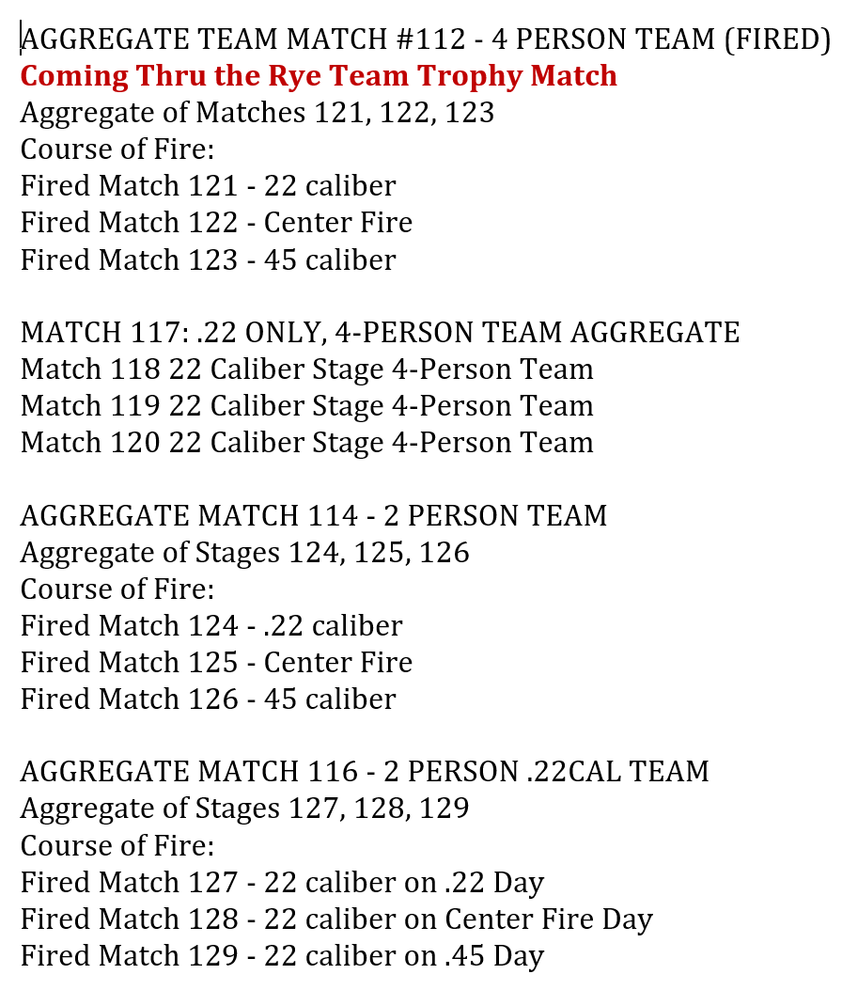
3rd NRA AWARD $10 ( to each firing member )
SPECIAL TEAM AWARDS
Open
Service
Police
State Association
Junior
Military Veteran

MATCH 121,122,123 (4 Person Team)
121 - Bob Shea High Standard Trophy Plaque awarded to each firing member
122 - Smith & Wesson Trophy Plaque awarded to each firing member
123 - Colt Trophy Plaque awarded to each firing member

MATCH 114 (2 Person Team )
1st Gold Medal ( X2 to each firing member )
2nd Silver Medal ( X2 to each firing member )
3rd Bronze Medal ( X2 to each firing member )

MATCH 116 ( 2 Person Team 22 only )
1st Gold Medal ( X2 to each firing member )
2nd Silver Medal ( X2 to each firing member )
3rd Bronze Medal ( X2 to each firing member )

MATCH 124 - 129
1st Fired Match 127 - 22 caliber on .22 Day NRA Medalion ( X2 to each firing member )
1st Fired Match 128 - 22 caliber on Center Fire Day NRA Medalion ( X2 to each firing member )
1st Fired Match 129 - 22 caliber on .45 Day NRA Medalion ( X2 to each firing member )

MATCH 115: 3-PERSON PREIMINARY TEAM
No awards

EXCELLENCE IN COMPETITION MATCHES

22 RIMFIRE EIC
Results announced on the line
Fee: $20
COURSE OF FIRE
.22 Rimfire 30 shot National Match Course
FIREARM:
.22 Rimfire Pistol, as described in the CMP Rulebook
RULES:
Current CMP Rules apply
ENTRY:
Limited to the first 200 competitors, non-Distinguished competitors have priority
AWARDS:
Gold, Silver and Bronze Place Medals will be awarded to the top three competitors, Distinguished or Non-Distinguished, by the CMP. Medals mailed to the competitors.
Achievement Pins will be presented to competitors at the end of the match, Distinguished or Non-distinguished.
Distinguished points will be awarded based on number of non-distinguished competitors. Points are awarded to non-distinguished competitors who place in the top 10% of all non-distinguished competitor scores, as described in the CMP Rulebook. These points will be awarded and mailed to the competitors by the CMP. Note: A minimum score of 260 is required for .22 Rimfire

SERVICE PISTOL EIC
Results announced on the line
Fee: $20
COURSE OF FIRE:
50 shot National Match Course of Fire
Firearm:
Service Pistol as described in the CMP rulebook
Rules
Current CMP Rules
Entries:
Limited to the first 200 competitors. Non-distinguished competitors have priority.
Gold, silver and Bronze Place Medal will be awarded to the top three competitors, Distinguished or Non-Distinguished, by the CMP. Medals mailed to the competitors.
Gold, Silver & Bronze Achievement Pins will be presented to competitors at the end of the match, Distinguished or Non-distinguished.
Distinguished points will be awarded based on the number of non-distinguished competitors. Points are awarded to non-distinguished competitors who place in the top 10% of all non-distinguished competitor scores, as described in the CMP Rulebook. These points will be awarded and mailed to the competitors by the CMP. Note: A minimum score of 250 for service pistol.

